Enterprise Application Development in Java EE - SET01

**Enterprise Application Development in Java EE *- Exam Paper***

***Question*:**

In 2006, Hanoi University of Science and Technology have plan to build system : **S**tudent **I**nformation **S**ystem(sis), to manage all student with some information below: 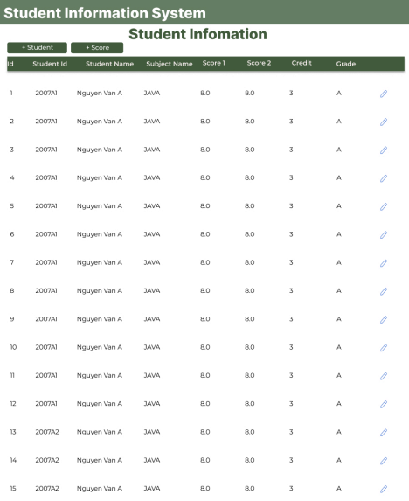Enterprise Application Development in Java EE – Set01 Practical Paper 1/3

Enterprise Application Development in Java EE - SET01

- Student information include: student id, student name, address.

- Score of student include: student id, subject id, score 1, score 2.

- Subject include: subject id, subject name, credit .

Using knowledge in subject Enterprise Application Development in Java EE to development this system.

1. A Employee of Training department inserts students (when clicked (**+ Student**)). 2. A Employee of Training department inserts the score of subjects for any student (when clicked **(+Score)**).

3. Display student information on the website like the picture below. Each student and a subject have Grade = 0.3×score 1 + 0.7 × score2. with table convert Score to Grade below.

|  |  |
| --- | --- |
| **Score** | **Grade** |
| 8.0 to 10 | A |
| 6.0 to 7.9 | B |
| 4.0 to 5.9 | D |
| less than 4.0 | F |

**Database information**:

**Database Name**: sis

**Script to create table and data**:

// *create table script*

**create table** student_t (

student_id **int auto_increment primary key**,

student_code **varchar**(20) **not null**,

full_name **varchar**(100) **not null**,

address **varchar**(255)

);

**create table** subject_t (

subject_id **int auto_increment primary key**,

subject_code **varchar**(20) **not null**,

subject_name **varchar**(100) **not null**,

credit **int not null**

);

**create table** student_score_t (

student_score_id **int auto_increment primary key**,

student_id **int**,

subject_id **int**,

Enterprise Application Development in Java EE – Set01 Practical Paper 2/3

Enterprise Application Development in Java EE - SET01

score1 **decimal**(5,2),

score2 **decimal**(5,2),

**constraint** fk_student_id **foreign key** (student_id) **references**

student_t(student_id),

**constraint** fk_subject_id **foreign key** (subject_id) **references**

subject_t(subject_id)

);

// *Insert sample data*

**insert into subject_t (subject_code, subject_name, credit) VALUES**

**('JAVA', 'Java Programming', 4),**

**('PHP', 'PHP Programming', 3),**

**('WDA', 'Web Development and Applications', 3);**

**insert into student_t (student_code, full_name, address)**

**VALUES ('2007A10', 'Nguyễn Văn A', 'Hà Nội');**

**insert into student_score_t (student_id, subject_id, score1,score2) VALUES (1, 1, 8.5,7.0);**

Marking Schema:

|  |  |
| --- | --- |
| **Question** | **Mark** |
| Question 1  Create Entity Subject  Create Entity Student | **3** |
| Question 1  Insert Student from website | **3** |
| Question 2  Create Entity Score | **3** |
| Question 2  Insert Score from website  Question 3  Display information student  Question 3  Convert score to Grade | **3**  **1**  **1** |
| Bonus Point: Design good UI/UX | **1** |
| **Total** | **15** |

Enterprise Application Development in Java EE – Set01 Practical Paper 3/3